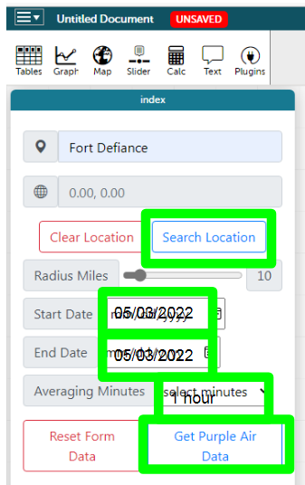Name:

Class Hour:

Day 4 Air Quality - Gather Data Practice

* Step 1: Go to website: <https://codap.concord.org/releases/latest/static/dg/en/cert/index.html?di=http://imeetsanghvi.github.io/temp/index>
* Step 2: Type 86504 or Fort Defiance, AZ
* Step 3: Click Search Location
* Step 4: Select Start Date 5/3/2022 - End Date 5/3/2022
* Step 5: Select Averaging Minutes: 60 minutes (1 Hour)
* Step 6: Use the results to complete the table.
* Step 7: Repeat with: Phoenix, AZ and Los Angeles, CA
* Note: If there are no data for any of the headings, write NA in the box

|  |  |  |  |  |  |
| --- | --- | --- | --- | --- | --- |
| **DATE/TIME** | **Temp** | **Humidity** | **Pressure** | **Visibility** | **Wind Speed** |
| **Fort Defiance, AZ** |  |  |  |  |  |
| **Phoenix, AZ** |  |  |  |  |  |
| **Los Angeles, CA** |  |  |  |  |  |

Look for the Today’s Air Quality link on the CODAP website:

* Step 1: Go to website: <https://codap.concord.org/releases/latest/static/dg/en/cert/index.html?di=http://imeetsanghvi.github.io/temp/index>
* Step 2: Type 86504 or Fort Defiance, AZ
* Step 3: Click Search Location
* Step 4: Select Start Date 5/3/2022 - End Date 5/3/2022
* Step 5: Select Averaging Minutes: 60 minutes (1 Hour)
* Step 6: Use the results to complete the table.
* Step 7: Repeat with: Phoenix, AZ and Los Angeles, CA
* Note: If there are no data for any of the headings, write NA in the box
* Add PM 10 and PM 2.5 to the table and record its data

|  |  |  |  |  |  |  |  |
| --- | --- | --- | --- | --- | --- | --- | --- |
| **DATE/TIME** | **Air Quality Index** | **Primary Pollutant** |  |  |  |  |  |
| **Fort Defiance, AZ** |  |  |  |  |  |  |  |
| **Phoenix, AZ** |  |  |  |  |  |  |  |
| **Los Angeles, CA** |  |  |  |  |  |  |  |

Reflection: When you see an Air Quality Index number, how do you know it is “good air quality” or “bad air quality”?