** Window Rock High School**

**Project-Based Learning (PBL)**

**Submitted by: GRACE CABUGUAS SAGARIO, ELA I-II Teacher**

**SY: 2021-2022 Research Project: Negativity in the Media**

Begin with a discussion about what “media” is, and bring in examples. Talk about what each kind of media (newspapers, music, news sites, etc.) is used for. Move on to examples of the messages conveyed by certain types of media, and how this message is articulated. Then assign groups to create their own “media” (a website, a newspaper article, a commercial, etc.). Have each group work on generating a message (positive vs. negative).

**"Exploring Media Messages"**

**Estimated Time of Completion:** Two to four 50-minute periods

[I. Summary](http://www.pbs.org/inthemix/educators/lessons/selfimage1/#summary)  
[II. Objectives](http://www.pbs.org/inthemix/educators/lessons/selfimage1/#objectives)  
[III. Materials Needed](http://www.pbs.org/inthemix/educators/lessons/selfimage1/#materials)  
[IV. Procedure](http://www.pbs.org/inthemix/educators/lessons/selfimage1/#procedure)  
[V. Classroom Assessment](http://www.pbs.org/inthemix/educators/lessons/selfimage1/#assessment)  
[VI. Extensions and Adaptations](http://www.pbs.org/inthemix/educators/lessons/selfimage1/#extensions)  
[VII. Online Resources](http://www.pbs.org/inthemix/educators/lessons/selfimage1/#resources)  
[VIII. Relevant National Standards](http://www.pbs.org/inthemix/educators/lessons/selfimage1/#standards)

**I. Summary:**

For **Grades** **9th-10th** . This lesson uses discussion and activity to help students explore how advertising and the media affect self-image.

**II. Objectives:**

* To learn to recognize negative aspects of advertising and how they exploit young people
* To explore where each individual stands on the issues of advertising and self-image
* To examine how one's own style and techniques are defined and who defines them
* To provide students with tools to feel stronger within themselves by looking at their own values and ideas
* To give participants guidance in taking a stand against negative media images
* To help students learn to believe in themselves and not compare themselves to unrealistic model images

**III. Materials Needed:**

* Powerpoint Presentation and/or Prezi Presentation (Digital)
* Poster board or easel
* A wide variety of popular magazines with teenagers. Be sure to also include popular mainstream adult magazines such as People, Vogue, Elle, Glamour, etc.
* Camera (Optional)
* Construction paper, markers, tape, glue

**IV. Procedure:**

**Part One:**

1. Begin by asking students to brainstorm a list of women who display or are identified with feminine ideals, and build a list on the blackboard or an easel. Ask them to identify which women would be considered the ideal "woman". Encourage them to list all types of celebrities: movie stars, music stars, athletes, models, etc. List suggestions as they come up.
2. Repeat the process with masculine ideals.
3. Break down "ideal" images of women and men even further by brainstorming a list of physical features that the media focuses on. For women, likely suggestions will be: breasts, hair color, legs, etc. For men, likely suggestions might be: arms, chest, legs, posterior, etc. You might then talk a bit about how often-- and in what way-- the media highlights non-physical qualities such as intelligence, sense of humor, and kindness.
4. Discuss some of the "role models" and "ideals" from years past. Who was considered ideal in the 1970's? What about the 1950's? How have ideals changed? What caused the change? To further illustrate the point and spark discussion, you might bring in old magazines from these eras.

**Part Two:**

1. Prepare in advance examples from magazines, newspapers etc that depict negative advertising.
2. Conceal what the ad is trying to sell.
3. Make overheads of the ads. It's best if you can use a color copier for the colored ads.
4. Display the ads on an overhead projector and encourage students to guess what the picture is advertising. This should provoke a discussion and begin to bring to the participant's attention the aspects of self-image related to advertising. Discuss whether or not the girls are more likely to purchase that particular product based on the way it is displayed. How should it be marketed so they would buy it?
5. To wrap up the activities and discussions, explain to students that they will be creating an "Magazine Ad Review" booklet of their own (which can be an in-class assignment or done as homework):
   * Ask students to search magazines for ads that reflect both positively and negatively on their self-image.
   * Students will then tape or glue each ad to a piece of contruction paper, writing a short commentary on it and whether it presents negative or positive images.
   * If the advertisement is negative, students should write what changes could be made to make it positive.
   * "Bind" the pages together in a booklet with staples or string.
   * The last page of their booklet might feature an essay on what they believe defines human beauty, their opinion about how the media portrays young people, and what they learned from this lesson.

**V. Classroom Assessment:**

**Score student work accordingly on:**

* Class discussion and participation
* Completion of poster or booklet on negative ads, with descriptive sentences about what makes them negative and what could make it a positive advertisement.
* Completion of letters to companies
* Completion of extra activities as assigned
* Extra credit given for exploring advertising in their local neighborhoods and communities.

**VI. Extensions and Adaptations:**

* Have students write down at least 5 or more positive personality traits about themselves and 5 positive physical traits. It can be very difficult to get adolescents and teens to acknowledge positive characteristics about themselves. In turn, you may also go around the room and have each student make a positive comment about every other student in the room. An alternative to having teens list positive traits about themselves is to have them fill in blanks such as: I am great at ________________, I have beautiful ___________, I am a fantastic _____________, etc.
* Instruct the students to list things they value about themselves. Why do they value these things? Where did these values come from? Are they learned from family or friends? Or the media? Uniquely belong to them? Discuss what values they have are at risk of being compromised by the images portrayed in the media.
* Have the group design their own positive ads, through words or taking photos.
* Make posters of positive words and images related to teens.
* Have students write letters to companies that depict teens in a negative light, expressing their feelings about the issues.
* Have students write a letter to a celebrity they look up to that participates in negative advertising explaining how it affects them and makes them feel.
* Create a collage or booklet specifically on gender-specific ads for toddlers and young children (i.e. ad that show little girls cooking in a toy kitchen and boys working with tools). Find ads that show gender equality.

**VII. Online Resources:**

* PBS **In the Mix** - "Self-Image: The Fantasy, The Reality"  
  [www.pbs.org/mix/selfimage_index.html](http://www.pbs.org/mix/selfimage_index.html)
* PBS "Affluenza"  
  [http://www.pbs.org/kcts/affluenza](http://www.pbs.org/kcts/affluenza/)
* Dads And Daughters  
  [http://www.dadsanddaughters.org](http://www.dadsanddaughters.org/)
* Radiance Magazine (For All Size Women)  
  [http://www.radiancemagazine.com](http://www.radiancemagazine.com/)
* Girls, Inc.  
  <http://www.girlsinc.org/PROGRAMS>
* About-Face  
  [http://www.about-face.org](http://www.about-face.org/)

**VIII. Relevant Arizona Standards:**

* **Integration of Knowledge and Ideas:** Integrate and evaluate content presented in diverse media and formats, including visually and quantitatively, as well as in words.
* **Craft and Structure:** Use precise words and phrases, telling details, and sensory language to convey a vivid picture of the experiences, events, setting, and/or characters.

**Language Arts**

* Students will use descriptive language that clarifies and enhances ideas.
* Students will use a variety of sentence structure to express expanded ideas.

**ESS Modified Project Based Learning**

* Self-Regulation: Students will identify personal strengths and weaknesses
* Self-Regulation: Students will identify their basic values
* Self-Regulation: Students will remind self of strengths
* Self-Regulation: Students will use affirmation to improve sense of self
* Thinking and Reasoning: Students will understand and apply the basic principles of logic and reasoning
* **RUBRICS: *(or other forms of measurement)***

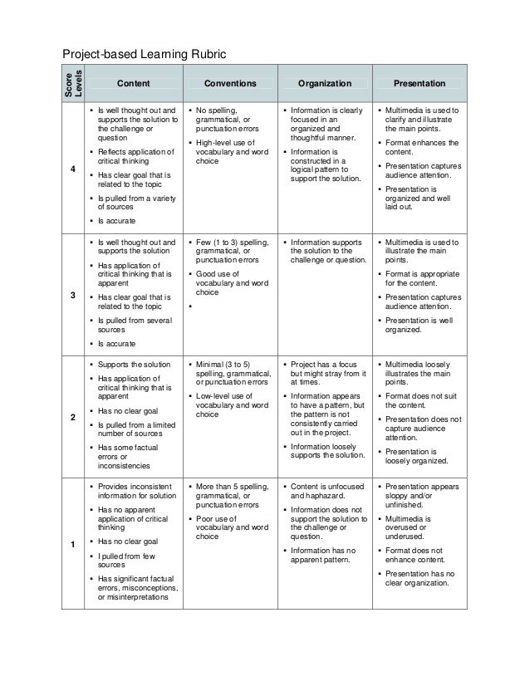

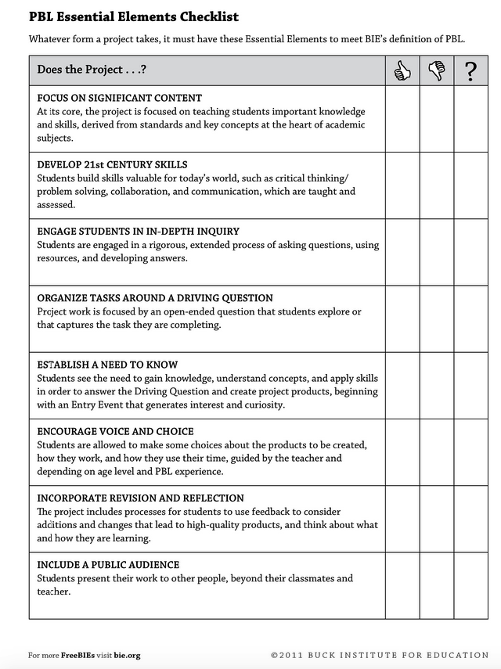

** Window Rock High School**

**Project-Based Learning (PBL)**

**CONNECT PROJECTS TO PURPOSE**

Project-based Learning (PBL): A method where students gain and apply skills by working on a project where they complete an in-depth inquiry into a specific topic or question. PBL allows for **real-world applications** and an in-depth understanding of the concepts your students learn.

Consider: The project is focused on teaching student knowledge and skills, derived from standards and key concepts at the heart of your content area.

**Student potential competencies:**

* Problem-solving
* Critical thinking
* Collaboration
* Communication
* Creativity/innovation
* Planning
* Research
* Product
* Others

**Student in-depth inquiry:** Students are engaged in an extended, rigorous process of asking questions, using resources, and developing answers.

* A project which allows students to understand a driving question toward their exploration or self-discovery about the specific topic assigned

**Look Fors:**

* Topic
* Objective

(standards specific to level/subject)

* Goals/Outcome (teacher defined learning goals)
* Specific, Measurable, Attainable, Research-based or Relevant, Timely (schedule of when project is due)
* **Rubrics** (or other form of measurement)